# ChangeLog

|  |  |  |
| --- | --- | --- |
| **Date** |  | **Changes** |
| 12-03-18 |  | First copy of the functional design |
|  |  |  |
|  |  |  |
|  |  |  |
|  |  |  |
|  |  |  |
|  |  |  |
|  |  |  |
|  |  |  |

# Story and background

Stop the hunter is a game where you’re against different AI, they are the hunters and you are the activist. As the activist you are there to stop them from hunting the animals. You shoot the hunter before it shoots the animals. But don’t shoot the animals!

|  |  |  |  |  |
| --- | --- | --- | --- | --- |
| **Characters** |  | **Description** |  | **Purpose** |
| Hunters |  | Are hunting the wild animals |  | Shoot them to stop them from hunting animals |
| Animals |  | Are being hunted by the hunters |  | Save them by shooting the hunters and lose points if you shoot them |

# Screen flow

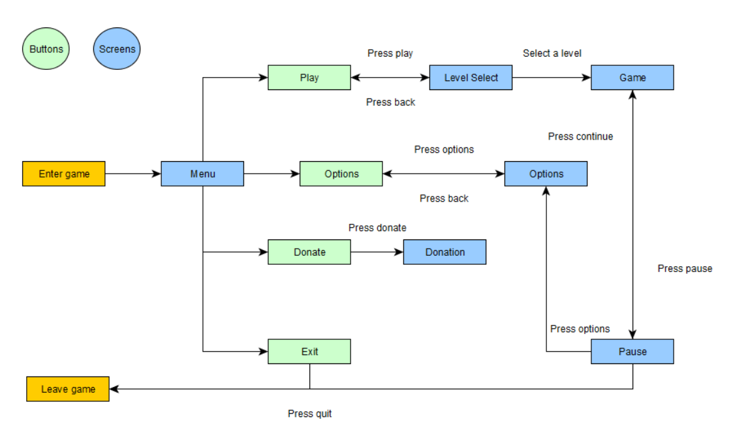

# Wireframes

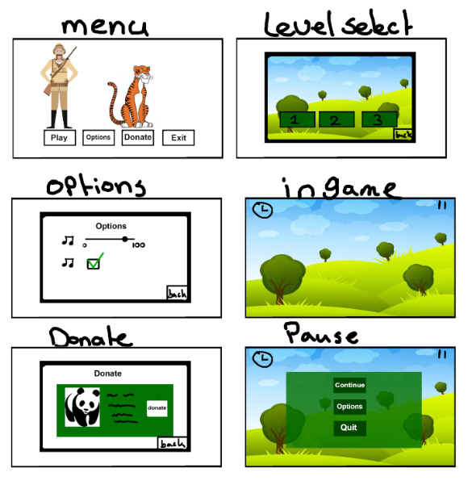

# Interactive Objects

|  |  |  |  |  |  |  |
| --- | --- | --- | --- | --- | --- | --- |
| **Object** |  | **Type** |  | **Does** |  | **How to Use** |
| Play Button |  | Button |  | Plays the game |  | finger tap |
| Options Button |  | Button |  | Opens the option menu |  | finger tap |
| Donation Button |  | Button |  | Opens the donation menu |  | finger tap |
| Exit Button |  | Button |  | Exits the game |  | finger tap |
| Back Button |  | Button |  | Goes back to the menu |  | finger tap |
| Hunters |  | AI |  | Can be shot to gain points |  | finger tap |
| Animals |  | AI |  | Can be shot to lose points |  | finger tap |

# Behaviors

|  |  |  |  |  |  |
| --- | --- | --- | --- | --- | --- |
| **Type** |  | **Description** |  | **How does it do it?** | **Expectable situations** |
| Button |  | When clicked something happens |  | When you click with your mouse something happens (what the name of the button says) | Plays the game, opens the option menu, opens the rules menu, exits the game, goes back to the previous screen, opens the pause menu |
| AI |  | Will pick a position on the map and shoots the animals |  | By using positions on the map it will pick a free spot and stand there to shoot the animals |  |
| Scoreboard |  | Shows the player the score of every other player |  | If you open op the score menu it will show how many points every player scored and how you get score | Shows the amount of animals you’ve saved at the end |
| Timer |  | Keeps track of the time you have left |  | Counts down from a timer |  |
| Player |  | Everything the player can do will be done here |  | It takes the input from the player, and uses it. |  |

# Object relationships

